Approach to Solve

•For each member, start a mongod and specify the replica set name through the

replSet option

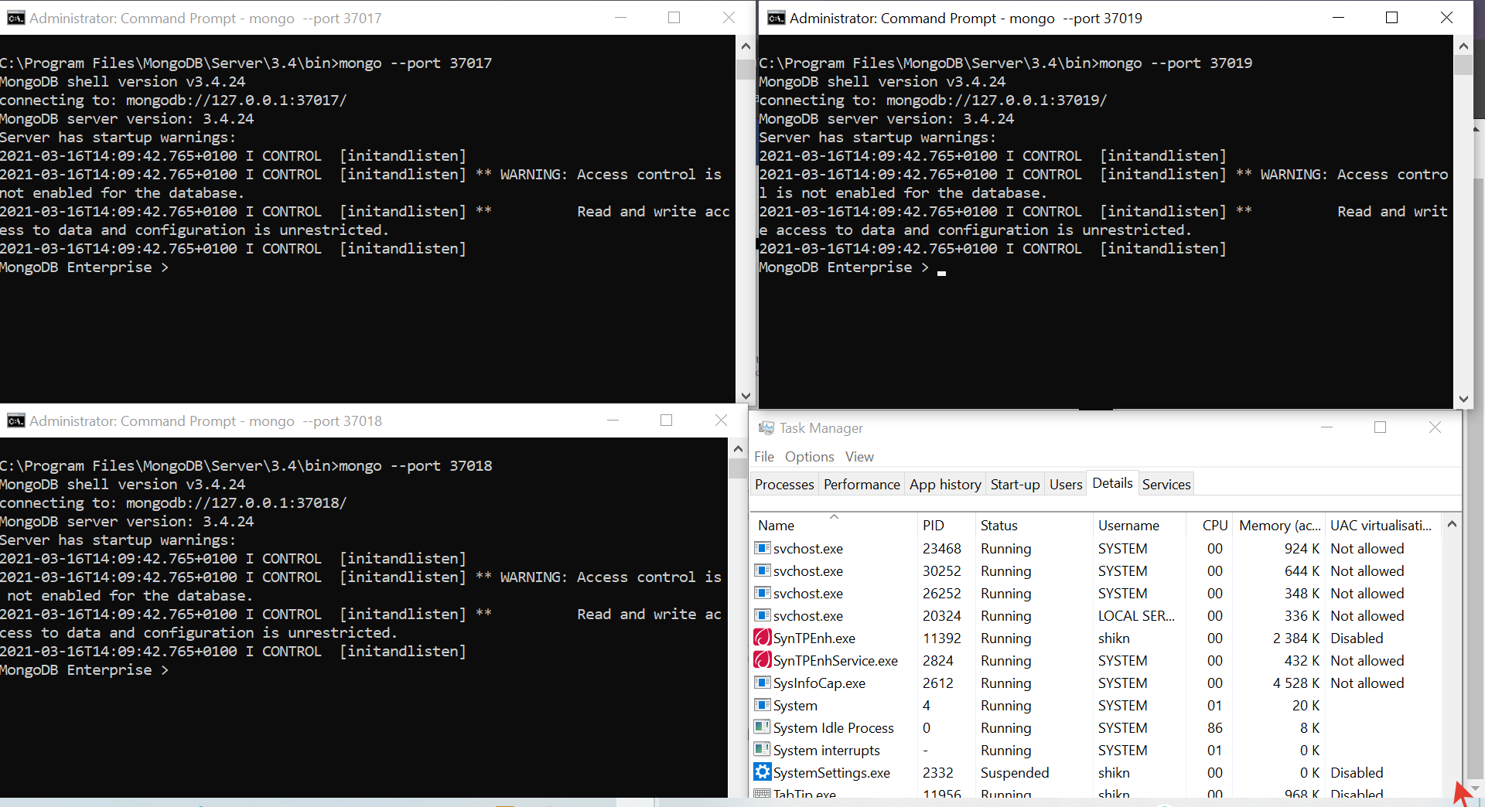

•Create and configure Primary server

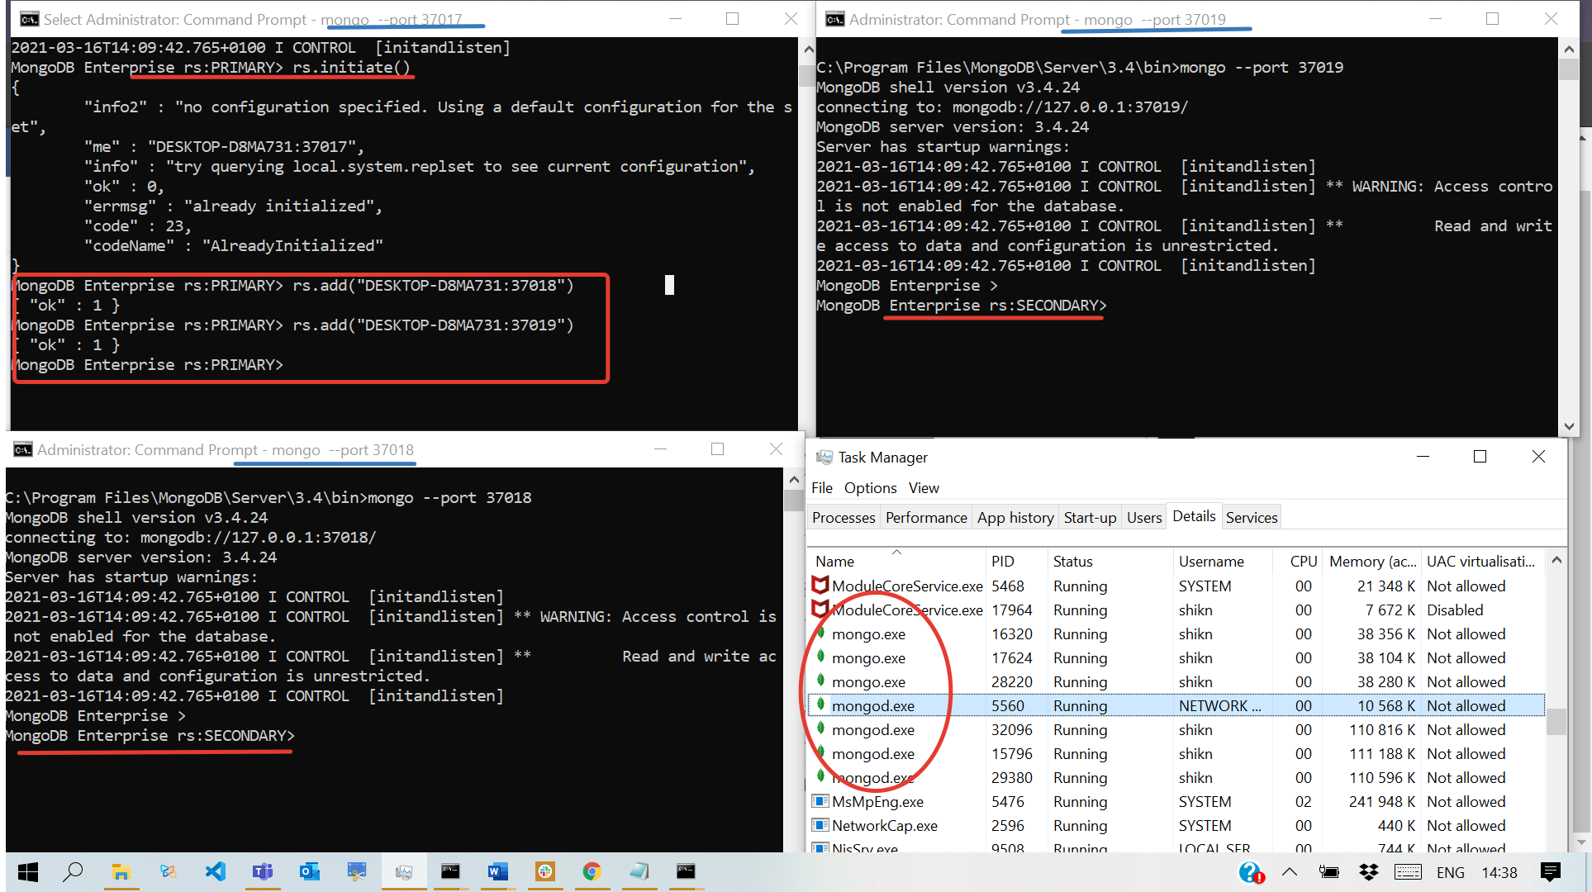•Create and configure secondary replica members

• Check the status of replica sets

1. Port 37017 status

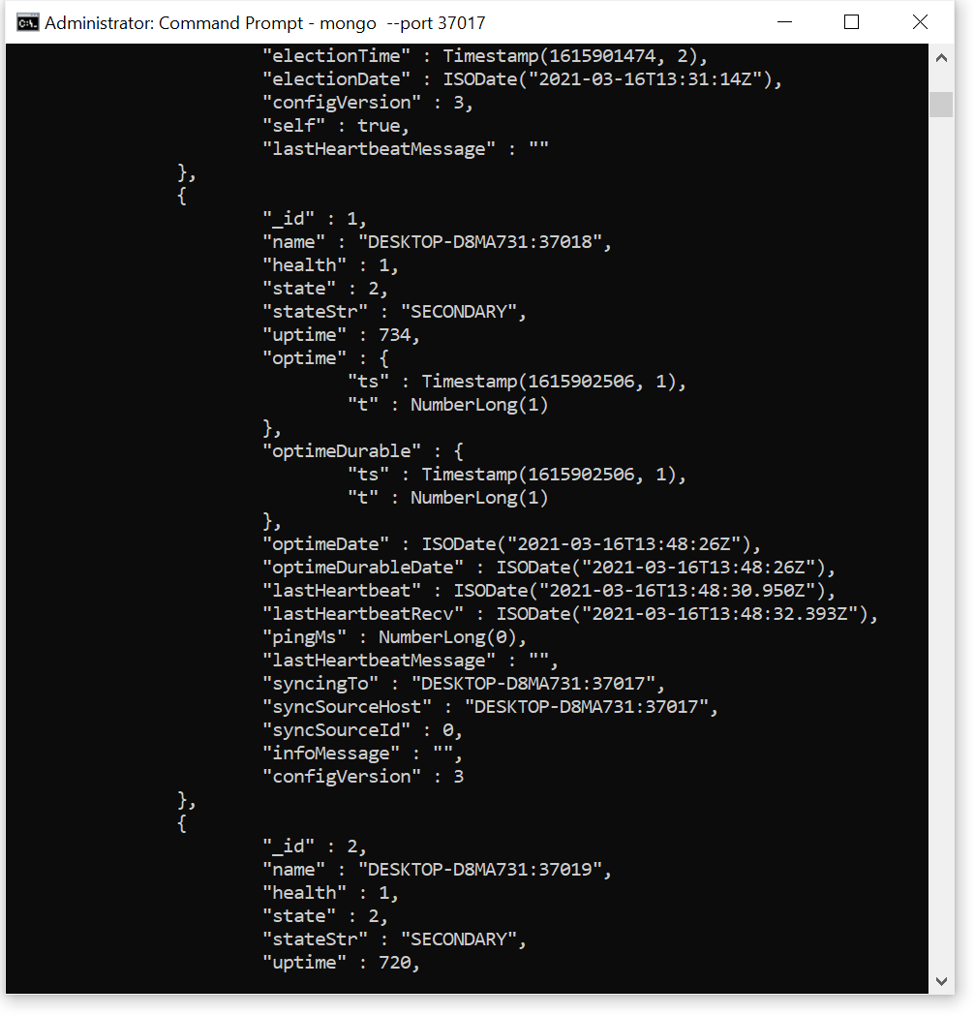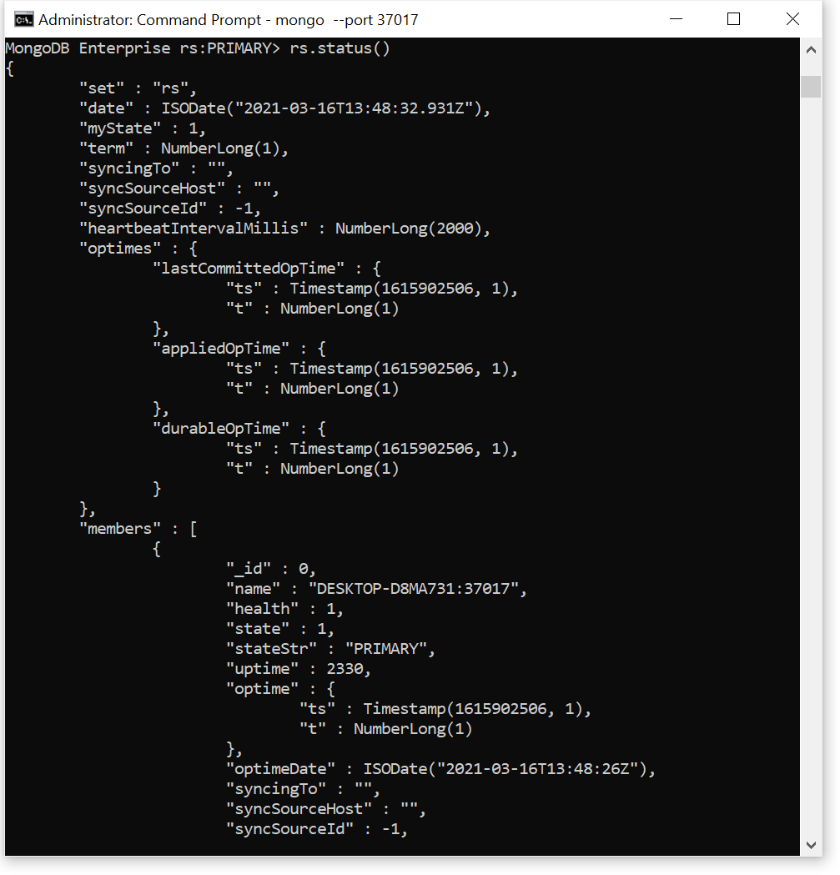

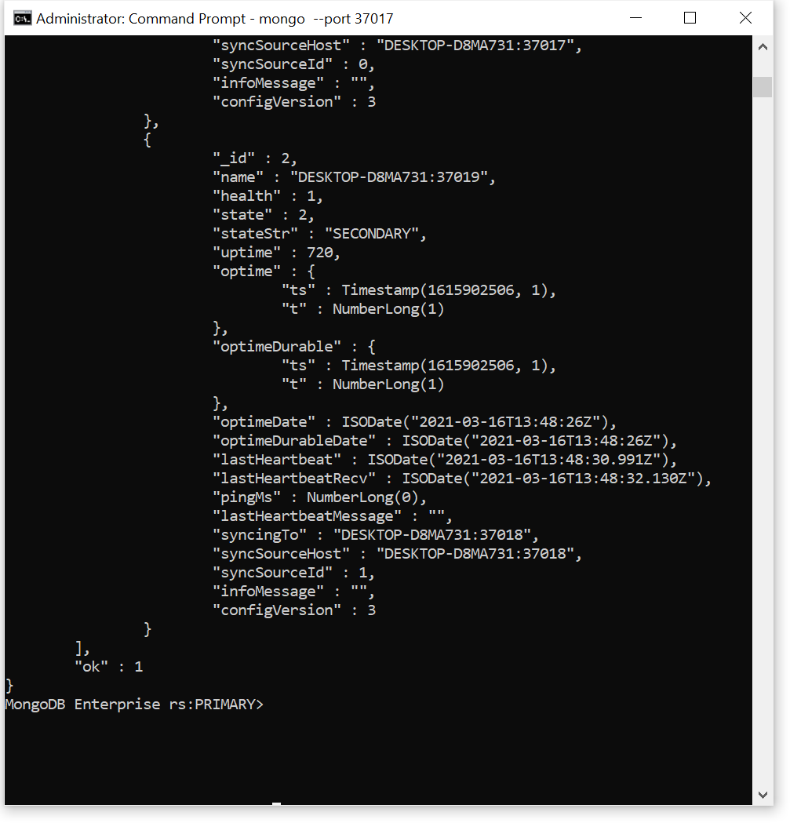

1. Port 37018 and 3719 status

